Innovation Colour Guide



Light Blue

R: 39 G: 167 B: 223

#27a7df



Green

R: 121 G:198 B:144

#79c6690



Purple

R:184 G:133 B:186

#b885ba



Orange

R: 233 G:109 B:71

#e96d47



Pink

R: 238 G:54 B:111

#ee366f



Teal

R: 0 G: 177 B: 174

#00b1ae

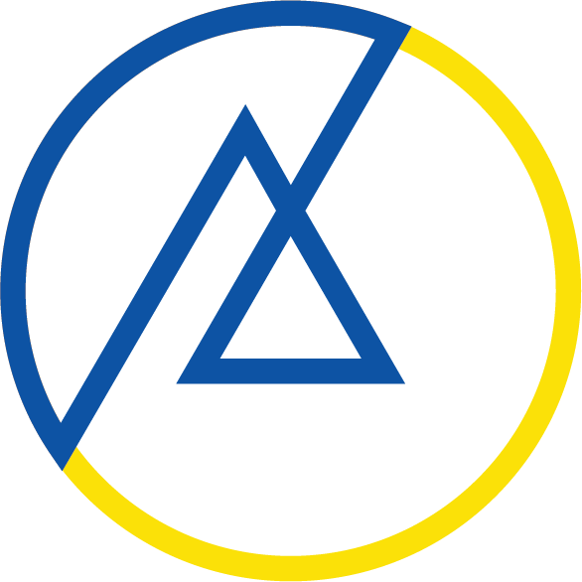

Blue

R: 7 G: 84 B: 163

#0754a3

Yellow

R: 253 G: 222 B: 0

#fdde00